# Basic Design Aims

The game is broken up into roughly 20minutes chunks with events happening every 20minutes or so. These events could include:

1. Player inventory is full so need to sell items (go back to town)
2. Player levels up
3. Player gains a power bit of wargear

To achieve this a number of probabilities are adjusted to make these events occur more often, for example the longer a player plays without receiving a more power wargear the more likely they are to receive one.

# To do List

## Key Functionality

### Item System

1. Pick up items of the floor
2. Buy items from a shop
3. Sell items at a shop
4. Drop Item on the floor
5. Display statistics on items

### Weapons Systems

1. Equipping 2 2-handed weapons has a disadvantage
2. Inaccuracy of range weapons

# Polish

## Enhanced game play

### Camera Work

1. Camera shake on damage
2. Camera shake on shooting weapon
3. Camera shake on levelling up

# Lessons Learnt

## Clothes System

Collisions within the mesh with the clothes are very important:

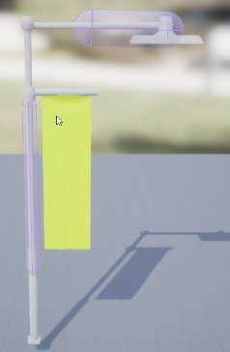The collider for this street light and banner is on the pole so it does not interact with banner (yellow) until it moves and contacts it. But if the banner was inside the collider it would cause issues.

Also the value that is ‘painted’ onto the vectors seems to affect how much the wind can affect the vector, higher values means it can move further